A

PROJECT PHASE - 1

Report On

**“Edushare- Resource Sharing Application”**

Submitted In Partial Fulfillment Of The Requirements For The

Degree Of

**BACHELOR OF TECHNOLOGY**

**( SEMESTER VII )**

**In**

**Computer Science And Engineering**

SUBMITTED BY

Mr. Tanishk Wagh (2165451242081)

Ms. Preeti Rajpure (2165451242053)

Mr. Omkar Wagh (2165451242072)

Mr. Mandar Shinde (2165451242069)

Uder the supervision of

**Mr. PATHAK. P. A**



Department Of Computer Science And Engineering

**ARVIND GAVALI COLLEGE OF ENGINEERING SATARA**

**2024-25**

**Certificate**

This is certify that the Project Phase - 1 report entitled

**“Edushare- Resource Sharing Application”**

is a bonafide work carried out by;

Mr. Tanishk Wagh (2165451242081)

Ms. Preeti Rajpure (2165451242053)

Mr. Omkar Wagh (2165451242072)

Mr. Mandar Shinde (2165451242069)

Uder Our Supervision During The Year **2024-25** And Submitted To The Faculty Of Computer Science And Engineering , AGCE Satara From **DBATU, LONERE**

In Partial Fulfilment Of The Requirements For The Award Of The Degree Of Bachelor Of Technology In Computer Science And Engineering.

Mr. Pathak P.A Mr. Pathak P.A

**(Project Guide) (Project Co-ordinator)**

Dr.Bhosale V.K

**(HOD) (Principle)**

**(Internal Examiner) (External Examiner)**

**UNDERTAKING**

We hereby declare that the details furnished above are true and correct to the best of our knowledge and belief and we undertake to inform authorities about any changes there in, immediately. In case any of the above information is found to be false or untrue or misleading or misrepresenting, we are aware that we may be held liable for it.

|  |  |  |  |
| --- | --- | --- | --- |
| Sr.No | Name Of Student | Roll No | Sign |
| 1 | Tanishk wagh | 2165451242081 |  |
| 2 | Preeti Rajpure | 2165451242053 |  |
| 3 | Omkar Wagh | 2165451242072 |  |
| 4 | Mandar Shinde | 2165451242069 |  |

Place : Satara

Date :

**Acknowledgement**

It is our privilege to acknowledge my deep sense of gratitude to my guide Mr. Pathak P.A in Computer Science and Engineering at Arvind Gavali College of Engineering, Satara for his valuable suggestions and guidance throughout our course and the timely help given to us in completion of our project work.

We are thankful to Principal , Arvind Gavali College of Engineering, Satara and Head of Computer Science and Engineering department Dr. Bhosale V.K for their kind Co- Operation & moral support.

Finally, we wish to express our sincere thanks to all the staff members of Arvind Gavali College of Engineering, Satara for their direct and indirect help during our project

Place: Satara

Date :

**ABSTRACT**

The Resource Sharing Application is a dynamic platform designed to facilitate the sharing and exchange of educational resources among students. Developed using HTML, CSS, JavaScript, and PHP, the application provides an intuitive interface for users to access and contribute learning materials such as lecture notes, e-books, videos, and other academic resources. To enhance usability, the application integrates advanced features powered by AI and machine learning, including personalized recommendations and intelligent search functionalities.

A robust database management system ensures secure and efficient storage of user-contributed resources, enabling seamless access and retrieval. The platform also includes a chatbot to assist users in navigating the website, understanding its features, and providing direct links to relevant resources.

This innovative application fosters a collaborative learning environment by promoting resource sharing, reducing duplication of efforts, and enabling students to benefit from a diverse pool of knowledge. It is an essential tool for enhancing the accessibility and quality of education in academic communities.

**CONTENTS**

1. ABSTRACT
2. CONTENTS
3. LIST OF FIGURE

CHAPTERS PAGE NO

**1.INTRODUCTION**

1.1 General Introduction

1.2 Problem Statement

1.3 Objective Of The Present Work

**2. LITERATURE REVIEW**

2.1 literature Review

**3.SOFTWARE REQUIREMENTS**

3.1 Functional Requirements

3.2 Non-Functional Requirements

3.3 Technical Requirements

3.4 Architecture

3.5 Dfd

**4. HARDWARE REQUIREMENTS**

4.1 Development & Testing Environment

4.2 Production Environment

**5. RESULT & CONCLUSION**

5.1 Result & Discussion

5.2 Conclusion

5.3 Future Scope

**6. REFERENCES**

6.1 Research Papers

**LIST OF FIGURES**

|  |  |  |
| --- | --- | --- |
| **Figure No** | **Caption** | **Page No** |
| **3.4.1** | System architecture |  |
| **3.5.1** | Zero level dfd |  |
| **3.5.2** | Level 1 dfd |  |
| **3.5.3** | User side dfd |  |
| **3.5.4** | Admin side dfd |  |

**Chapter 1**

**INTRODUCATION**

**Chapter 1**

**INTRODUCTION**

**1.1 General Introduction**

Students often face problem while collecting notes and it interrupts their learning process.Our application will provide a platform for the students where they can come together for collaborative learning.

Students can share their notes/materials ( both handwritten and in document - PPT, PDF, DOC, etc. format) to the admin of the website through the whatsapp or Email so the admin can check the notes and add then into the application and the students from any branch or semester from the different universities can access for free.

In our platform users can upload their notes giving a short description and some keywords related to the subject, branch and semester. Other users can search the notes using those keywords which will provide them filtered results. Each user will have an account through they will access the application.

The platform is planned to be a **LEARN| SHARE | EDUCATE** platform which aims to increase effectiveness and conceptual clarity of students.

**1.2 Problem Statement**

Students often face challenges in accessing reliable and relevant academic resources, such as notes, project materials, tutorials, and guides. These challenges are exacerbated by the lack of a centralized platform that supports efficient sharing, discovery, and organization of resources. Existing solutions are often fragmented, outdated, or lack personalization, making it difficult for students to find what they need.

Furthermore, students require a platform that integrates emerging technologies like AI and machine learning to provide tailored recommendations, optimize search functionalities, and foster an engaging user experience. The absence of real-time support also limits user understanding and effective navigation of these platforms.

This project aims to address these issues by developing a feature-rich, AI-powered resource-sharing platform that streamlines access to academic resources while encouraging collaboration and knowledge exchange within the student community.

**1.3 Objective Of The Present Work**

The objective of this proposed **Edushare-resource-sharing application** is to design and develop a user-friendly, AI-powered platform that enables students to easily share, discover, and access academic resources while fostering collaboration and knowledge exchange. The system aims to:

1. **Centralize Academic Resources:**  
   Provide a unified platform where students can upload, access, and organize various academic resources, including notes, project files, tutorials, and reference materials.
2. **Facilitate Collaboration:**  
   Promote interaction among students by incorporating features like resource rating, commenting, and discussion forums to encourage feedback and knowledge sharing.
3. **Ensure Seamless Accessibility:**  
   Support multiple file formats (e.g., PDFs, images, videos) and provide mobile-friendly access to enable resource sharing on-the-go.
4. **Provide Real-Time Support:**  
   Integrate an AI-driven chatbot to assist users in understanding platform features, navigating the website, and resolving common queries promptly.
5. **Maintain Data Security and Privacy:**  
   Implement secure data storage, user authentication, and controlled access mechanisms to ensure the integrity and confidentiality of uploaded resources.
6. **Support Scalability:**  
   Design the application to handle increasing user traffic and accommodate future expansion, including additional features like advanced analytics and integrations with educational tools.

**Chapter 2**

**LITERATURE REVIEW**

**Chapter 2**

**2.1 literature Review**

|  |  |  |  |  |
| --- | --- | --- | --- | --- |
| **Sr.No** | **Author Name** | **Paper Name** | **Publication Year** | **Technology Used** |
| 1 | IEEE contributors | Empirical Study of Most Popular PHP Frameworks | 2019 | PHP frameworks (e.g., Laravel, CodeIgniter, Symfony) Proposes a PHP framework for improving modularity and performance |
| 2 | Xiaoming Chen,  Jian Zhang | The Applications of PHP, HTML, and MySQL in Development of Website – Query Function | 2021 | PHP, MySQL, HTML Discusses PHP's integration with databases and web interfaces |
| 3 | [Helene L Teitelbaum](https://www.researchgate.net/scientific-contributions/Helene-L-Teitelbaum-25471214?_tp=eyJjb250ZXh0Ijp7ImZpcnN0UGFnZSI6InB1YmxpY2F0aW9uIiwicGFnZSI6InB1YmxpY2F0aW9uIn19) | Resource Sharing Platforms in the Digital Era | 2023 | Strategies for developing robust resource-sharing platforms using open-source PHP |
| 4 | IEEE contributors | A Systematic Review of Collaborative Digital Platforms | 2023 | PHP and Angular for designing platforms that enhance digital collaboration and resource sharing |
| 5 | Faculty of Language Studies and Human Development | An Urban and Rural Educational Resource Sharing and Exchange Platform Based on Cloud Platform Access Technology | 2023 | Cloud computing and network platforms Proposes a cloud-based educational resource-sharing platform designed to connect urban and rural schools, facilitating the exchange of high-quality educational materials |
| 6 | Majid Zamiri and Ali Esmaeili | Methods and Technologies for Supporting Knowledge Sharing within Learning Communities: A Systematic Literature Review | 2023 | Diverse methods including collaborative learning platforms and online forums |
| 7 | [Andreas F. Molisch](https://ieeexplore.ieee.org/author/37279677800)  [Geoffrey Hinton](https://ieeexplore.ieee.org/author/37270925500) | Evolution of Resource Sharing Cooperation Based on Reciprocity in Peer-to-Peer Networks | 2024 | Examines how reciprocity models impact resource sharing in P2P social networks, providing insights into optimizing voluntary contributions and allocation mechanisms |

**Chapter 3**

**SOFTWARE REQUIREMENTS**

**Chapter 3**

**Software Requirements**

**3.1 Functional Requirements**

1. User Authentication and Authorization

- User registration (email, password, etc.)

- Login and logout functionality

- Role-based access control (admin, user, etc.)

2. User Profile Management

- View and edit personal profiles

3. Resource Management

- Create, edit, and delete resource listings

- Categorize resources (pdf , vedio links, mcq test links etc.)

4. Resource Search and Discovery

- Search resources by keywords, category, location, etc.

- Filter and sort search results

- View resource details

6. Notifications and Alerts

- notifications for important actions (request approval, new messages)

- In-app notifications for real-time updates

7. Messaging System

- Direct messaging between users

8. Admin Panel

- Manage users and resources

- View and manage system logs

- Handle disputes and issues

* 1. **Non-Functional Requirements**

**1. Performance**

- Fast load times (under 3 seconds for main pages)

- Efficient search and filtering capabilities

**2. Scalability**

- Support for a growing number of users and resources

- Ability to scale horizontally (adding more servers)

**3. Security**

- Data encryption (in transit and at rest)

- Protection against common vulnerabilities (SQL injection )

- Regular security audits

**4. Usability**

- Intuitive and user-friendly interface

- Mobile responsiveness

* 1. **Technical Requirements**

**1. Front-end Technologies**

- HTML, CSS, JavaScript

- Frameworks: javascript

**2. Back-end Technologies**

- Programming language: php

- Frameworks: javascript

**3. Database**

- Relational Database: MySQL

**4. APIs**

- RESTful API for client-server communication

- Third-party APIs for notifications, payments (if applicable)

**5. Hosting and Deployment**

- Cloud platform: AWS, Google Cloud, or Azure

- Containerization: Docker

- CI/CD tools: Jenkins, GitHub Actions

**3.4 Architecture**

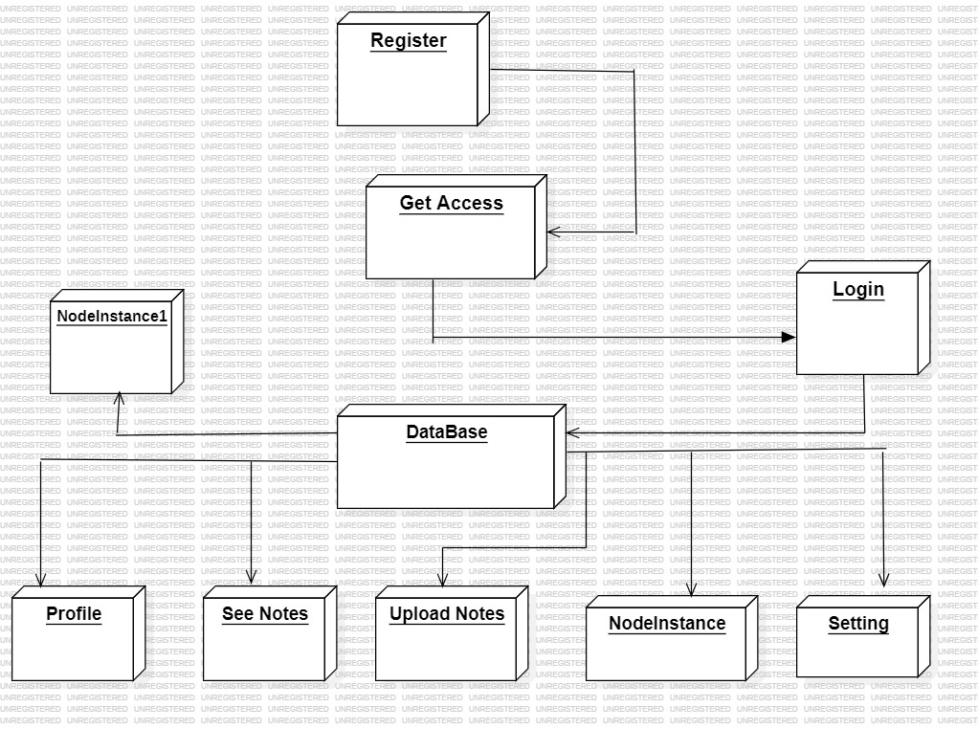

**(Fig 3.4.1)**

**3.5 Dfd**

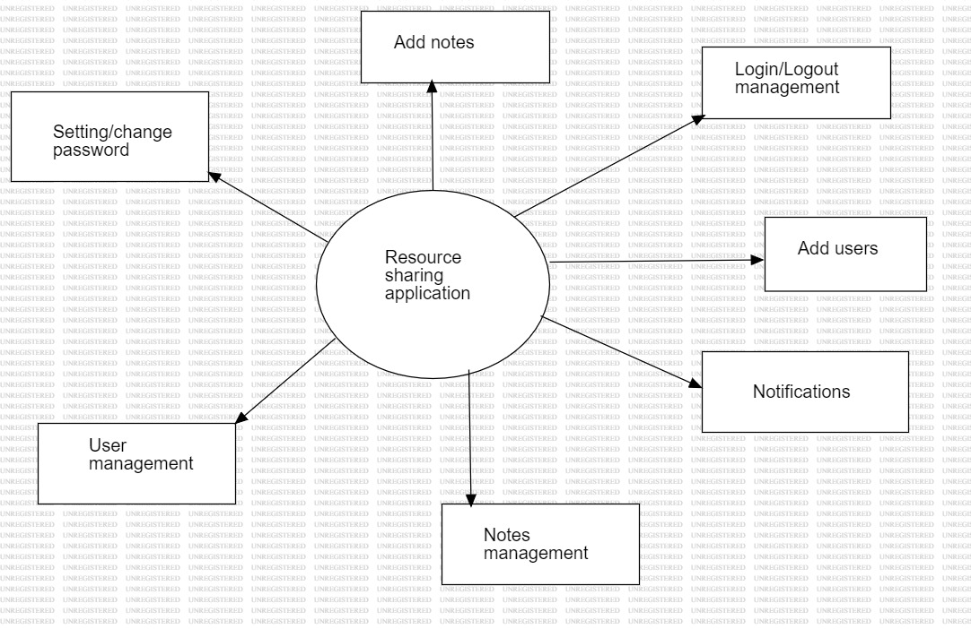

**Fig 3.5.1 ( Zero Level DFD )**

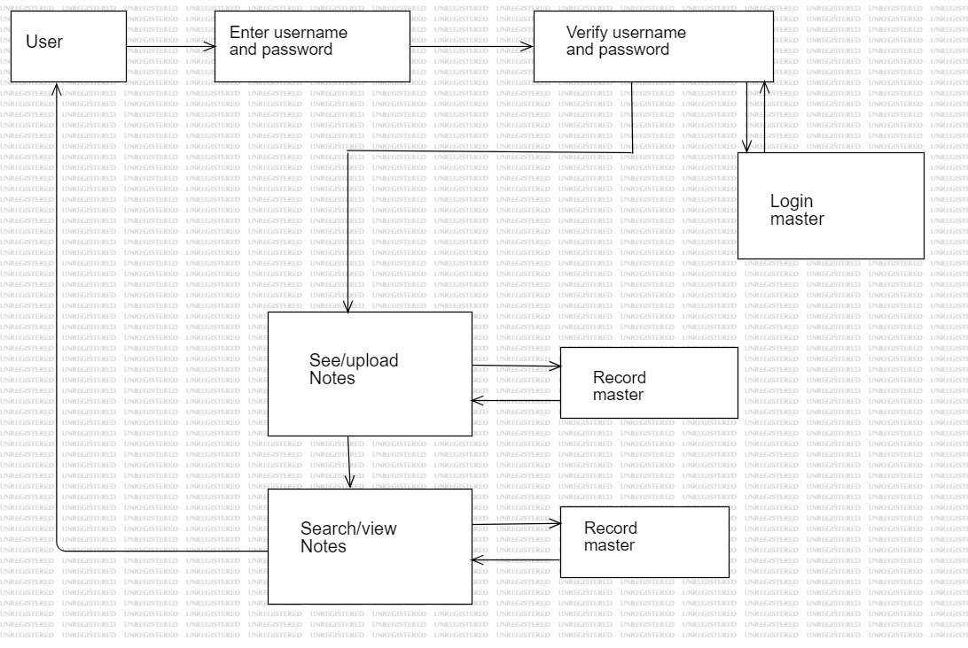

**Fig 3.5.2 ( level 1 Dfd)**

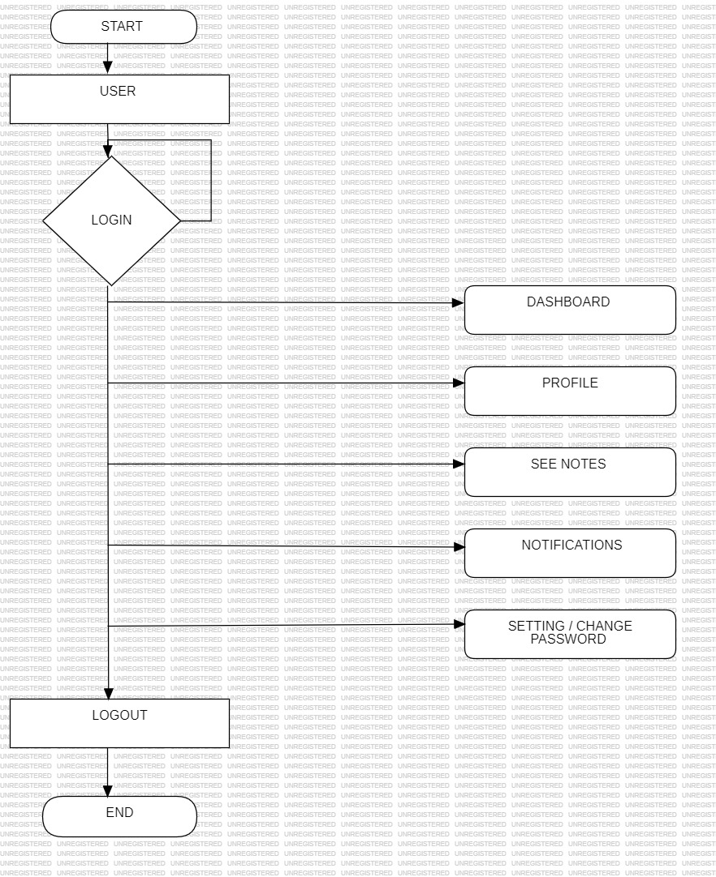

**Fig 3.5.3 (User Side Dfd)**

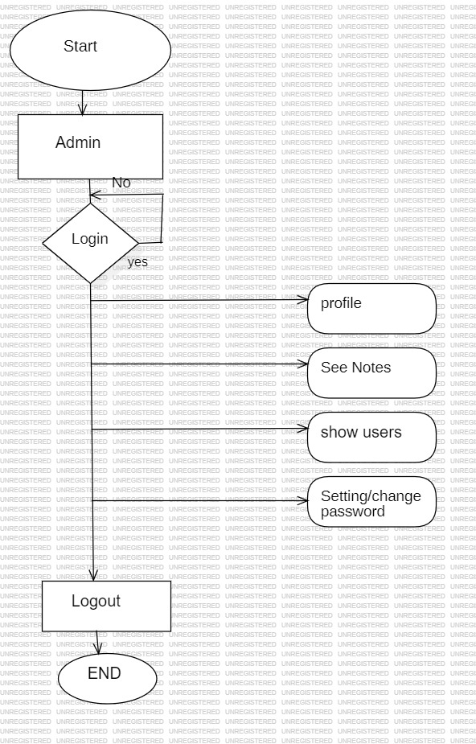

**Fig 3.5.4 ( Admin Side Dfd)**

**Chapter 4**

**HARDWARE REQUIREMENTS**

**CHAPTER 4**

**HARDWARE REQUIREMENTS**

**4.1 Development & Testing Environment**

**1. Developer Workstations**

- Processor: Quad-core CPU (e.g., Intel i5 or AMD Ryzen 5)

- RAM: 16 GB

- Storage: 512 GB SSD

- Network: High-speed internet connection

- Operating System: Windows, macOS, or Linux

**2. Local Development Servers (optional)**

- Processor: Quad-core CPU

- RAM: 16 GB

- Storage: 512 GB SSD

- Network: High-speed internet connection

**4.2 Production Environment**

**1. Web Server**

- Processor: 8-core CPU (e.g., Intel Xeon or AMD EPYC)

- RAM: 32 GB or more

- Storage: 1 TB SSD

- Network: Gigabit Ethernet connection

- Operating System:Linux (Ubuntu, CentOS, etc.)

**2. Database Server**

- Processor:8-core CPU

- RAM: 64 GB or more (dependent on the size of the database and number of concurrent connections)

- Storage: 2 TB SSD (consider NVMe for faster access)

- Network: Gigabit Ethernet connection

- Operating System: windows

**3. File Storage Server (for storing uploaded notes)**

- Processor: Quad-core CPU

- RAM: 16 GB

- Storage: Configurable based on storage needs (start with 2 TB HDD, scalable)

By carefully planning the hardware requirements and considering future scalability, you can ensure that your note-sharing application will perform well and accommodate growth efficiently.

**Chapter 5**

**RESULT & CONCLUSION**

**CHAPTER 5**

**5.1 Result & Discussion**

**Results: Step-by-Step Implementation**

**1. Admin Side**

**1.1. Admin Login**

* Step: The admin logs into the application using secure credentials.
* Implementation:
  + Admin login page is created using HTML, CSS, and JavaScript.
  + Login details are authenticated using a PHP back-end with data stored in a database.
* Result: Admin is redirected to the admin dashboard upon successful authentication.

**1.2. Dashboard Overview**

* Step: Admin accesses an overview of key statistics (e.g., total users, shared resources, pending approvals).
* Implementation:
  + Dashboard populated with dynamic data fetched from the database.
  + PHP is used for server-side data retrieval, and charts are displayed using JavaScript libraries like Chart.js.
* Result: Admin can view the system's current status at a glance.

**1.3. User Management**

* Step: Admin manages user accounts (approve/reject registrations, reset passwords, delete accounts).
* Implementation:
  + User table with CRUD functionality.
  + Approvals and actions trigger PHP scripts to update the database.
* Result: User accounts are efficiently managed to maintain platform integrity.

**1.4. Resource Management**

* Step: Admin oversees resources shared by users (approve/reject uploaded resources, delete inappropriate content).
* Implementation:
  + List of resources displayed with status indicators.
  + Admin actions directly update the database using PHP and SQL queries.
* Result: Only high-quality, approved resources are visible to users.

**1.5. Notification Management**

* Step: Admin sends notifications or announcements to users.
* Implementation:
  + Notification feature integrated using PHP and JavaScript for both broadcast and individual messages.
* Result: Users receive timely updates on their dashboards.

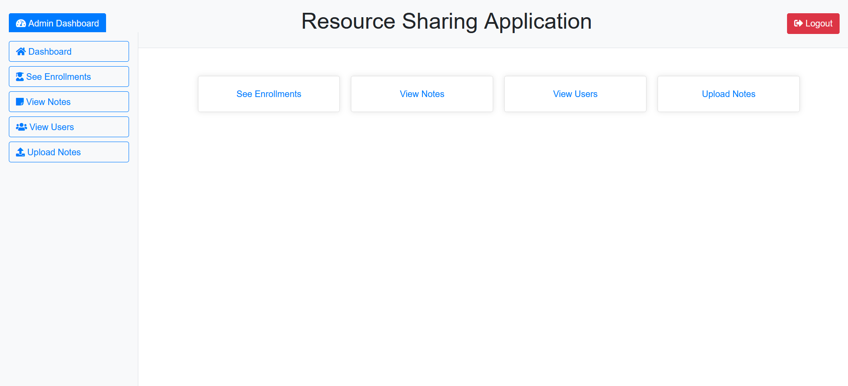 **\*Results \***

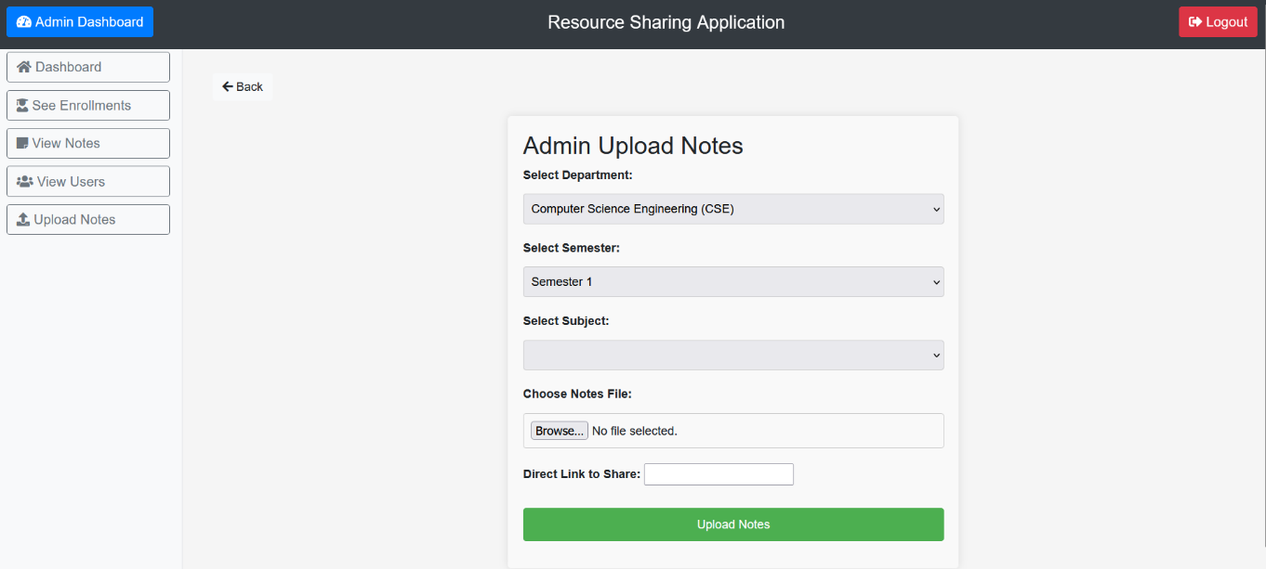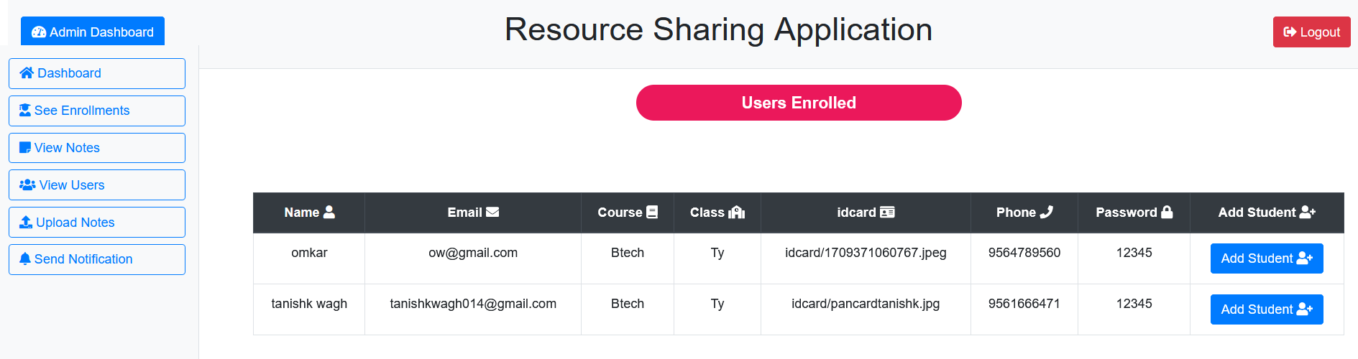

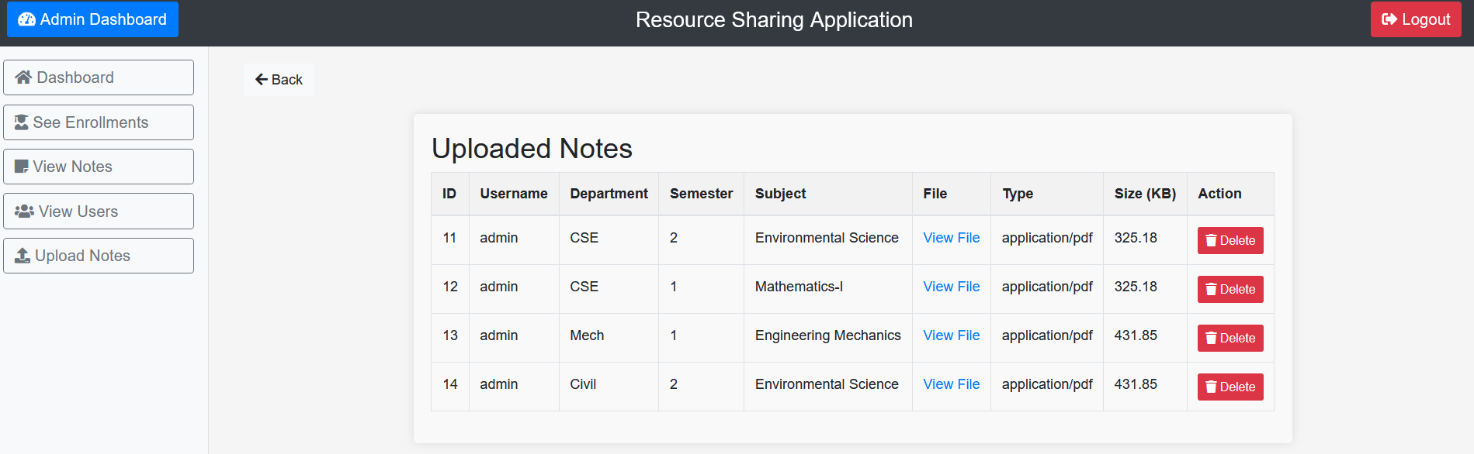

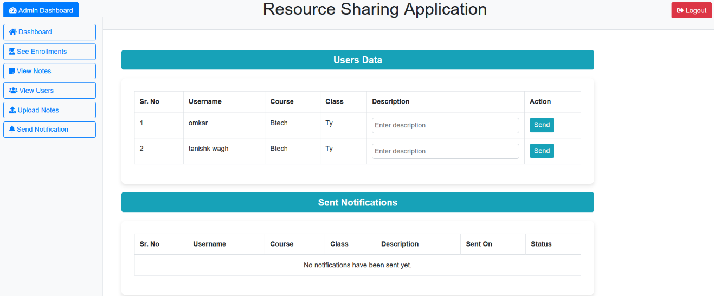

**2. User Side**

**2.1. User Registration**

* Step: New users register on the platform by providing their details.
* Implementation:
  + Registration form created with HTML and validated using JavaScript.
  + Data is stored in the database through a PHP script.
* Result: User receives a confirmation message and awaits admin approval.

**2.2. User Login**

* Step: Users log into the platform using their credentials.
* Implementation:
  + Secure login page implemented with PHP for authentication.
  + Sessions used to maintain user state.
* Result: User is redirected to the main dashboard upon successful login.

**2.3. Dashboard Access**

* Step: User views personalized content and features (e.g., uploaded resources, announcements).
* Implementation:
  + Dynamic dashboard content fetched from the database using PHP and displayed with JavaScript.
* Result: Users can navigate to other features easily.

**2.4. Resource Upload**

* Step: User uploads resources such as notes, assignments, or projects.
* Implementation:
  + File upload form with validation for file type and size.
  + Files stored in the server, and metadata is saved in the database.
* Result: Uploaded resources are submitted for admin approval.

**2.5. Resource Browsing and Download**

* Step: Users search for resources and download approved files.
* Implementation:
  + Search functionality implemented using SQL queries.
  + Download links provided for approved resources.
* Result: Users can access high-quality study materials.

**2.6. AI-Based Assistance**

* Step: Users interact with the AI chatbot for guidance and resource suggestions.
* Implementation:
  + Chatbot powered by machine learning or integrated with pre-trained NLP models.
  + Provides resource links and navigational help.
* Result: Enhanced user experience through quick assistance.

**2.7. Profile Management**

* Step: Users update their profiles (e.g., password reset, profile picture update).
* Implementation:
  + Profile settings form with validation.
  + Updates are saved in the database through PHP.
* Result: Users maintain updated and secure profiles.

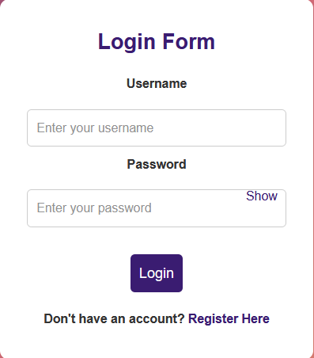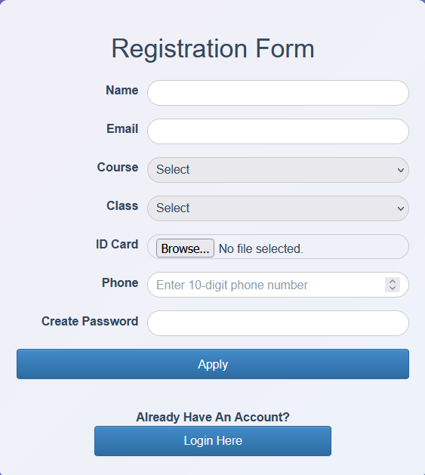

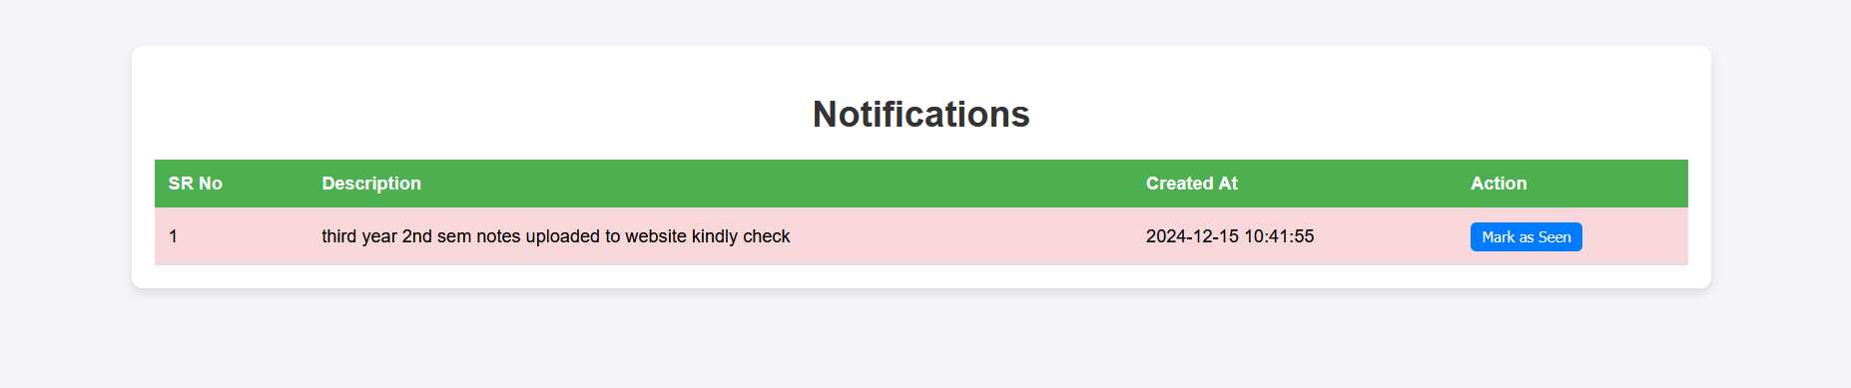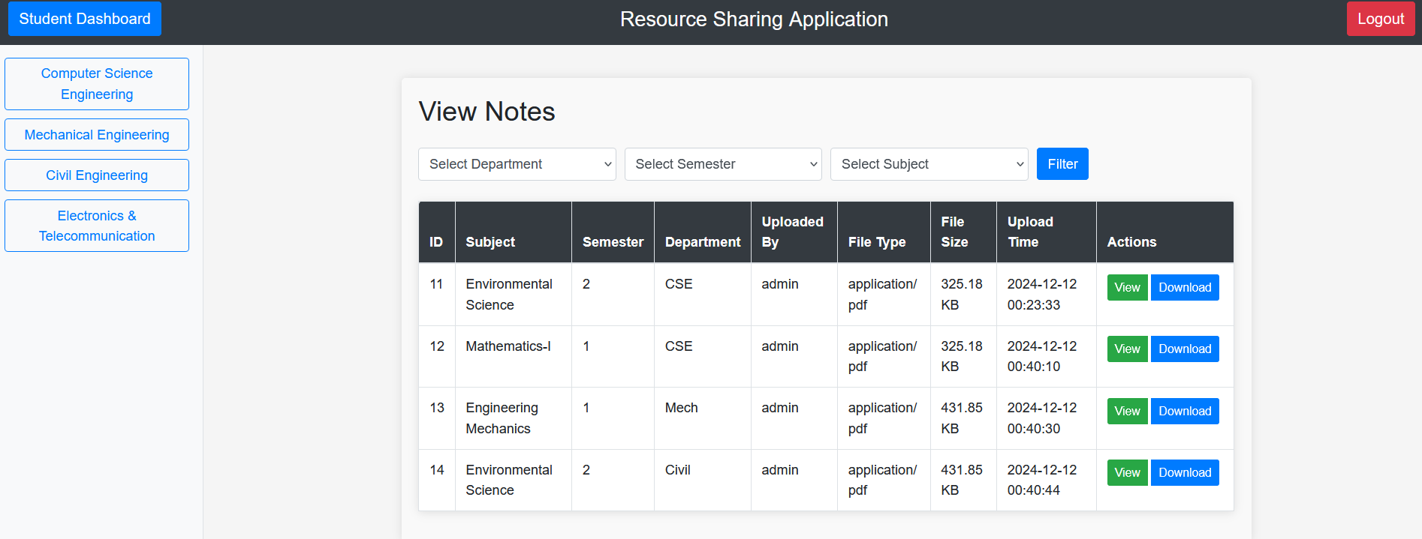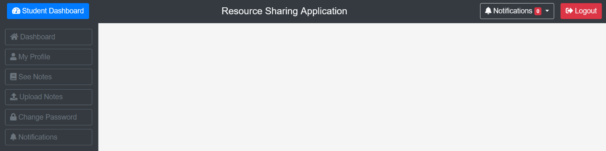

**3. Testing and Validation**

Both admin and user functionalities were tested rigorously to ensure the following:

* Secure login and registration process.
* Smooth file upload and download experience.
* Real-time updates to the dashboard.

**4. Observations**

* Admin-side tools ensure a high-quality user experience by filtering resources and managing users effectively.
* User-side features promote collaborative learning by allowing easy access to shared materials.

**5. Discussion**

The resource-sharing application effectively combined web technologies and AI to enhance the user experience. While HTML, CSS, and JavaScript ensured a user-friendly interface, PHP facilitated secure server-side operations. The integration of a recommendation system and chatbot added personalization and improved navigation. Challenges included optimizing the recommendation system with limited data and refining the chatbot for diverse queries. The platform successfully simplified resource sharing for students, fostering collaboration and accessibility. Future improvements could include advanced security features, larger datasets for better recommendations, and additional interactive tools to increase engagement.

**5.2 Conclusion**

In conclusion, a notes sharing application project offers numerous advantages such as enhanced collaboration, accessibility, organization, version control, and synchronization.

However, it also presents certain disadvantages including privacy concerns, dependency on internet connectivity, security risks, potential costs, and a learning curve for users.

Despite these drawbacks, the benefits of improved collaboration and accessibility often outweigh the challenges, making Resource Sharing Applications valuable tools for individuals and groups seeking to streamline their note-taking and information sharing processes.

**5.3 Future Scope**

The future scope of a notes sharing application project is promising, with opportunities for further enhancement and innovation. Some potential areas for future development include:

1. **Advanced Collaboration Features:** Introducing real-time collaboration features such as simultaneous editing, chat functionalities, and group discussions can enhance the collaborative experience for users.

2. **Enhanced Security Measures:** Continuously improving security protocols and implementing encryption techniques to safeguard user data and prevent unauthorized access or data breaches.

3. **Integration with AI:** Integrating artificial intelligence capabilities for features like automatic summarization, content recommendations, or smart tagging to improve note organization and accessibility.

4. **Cross-Platform Compatibility:** Ensuring seamless compatibility across various platforms and devices, including desktops, tablets, and mobile devices, to provide users with a consistent experience regardless of the device they use.

5. **Augmented Reality (AR) Integration:** Exploring the integration of AR technology to enable users to interact with their notes in immersive ways, such as virtual study environments or interactive 3D models.

6. **Accessibility Features:** Implementing accessibility features to ensure that the application is usable by individuals with disabilities, such as screen reader compatibility, voice commands, and customizable interfaces.

7. **Machine Learning Algorithms:** Leveraging machine learning algorithms to analyze user behavior and preferences, offering personalized recommendations, and improving the overall user experience.

8. **Blockchain Technology:** Exploring the use of blockchain technology for enhanced data security, transparency, and decentralization, ensuring that user data remains secure and tamper-proof.

**Chapter 6**

**REFERENCES**

**CHAPTER 6**

**6.1 Research Papers**

1. IEEE contributors, *“Empirical Study of Most Popular PHP Frameworks”*, 2023. Discusses PHP frameworks (e.g., Laravel, CodeIgniter, Symfony) and proposes a PHP framework for improving modularity and performance.
2. Xiaoming Chen, Jian Zhang, *“The Applications of PHP, HTML, and MySQL in Development of Website – Query Function”*, 2023. Explores PHP's integration with databases and web interfaces.
3. Helene L. Teitelbaum, *“Resource Sharing Platforms in the Digital Era”*, 2023. Provides strategies for developing robust resource-sharing platforms using open-source PHP.
4. IEEE contributors, *“A Systematic Review of Collaborative Digital Platforms”*, 2023. Explores PHP and Angular for designing platforms that enhance digital collaboration and resource sharing.
5. Faculty of Language Studies and Human Development, *“An Urban and Rural Educational Resource Sharing and Exchange Platform Based on Cloud Platform Access Technology”*, 2021. Proposes a cloud-based educational resource-sharing platform to connect urban and rural schools.
6. Majid Zamiri, Ali Esmaeili, *“Methods and Technologies for Supporting Knowledge Sharing within Learning Communities: A Systematic Literature Review”*, 2024. Reviews diverse methods, including collaborative learning platforms and online forums.
7. Andreas F. Molisch, Geoffrey Hinton, *“Evolution of Resource Sharing Cooperation Based on Reciprocity in Peer-to-Peer Networks”*, 2019. Examines how reciprocity models impact resource sharing in P2P networks, optimizing voluntary contributions and allocation mechanisms.